Trust Details
Anjali Adarsha Educational Trust
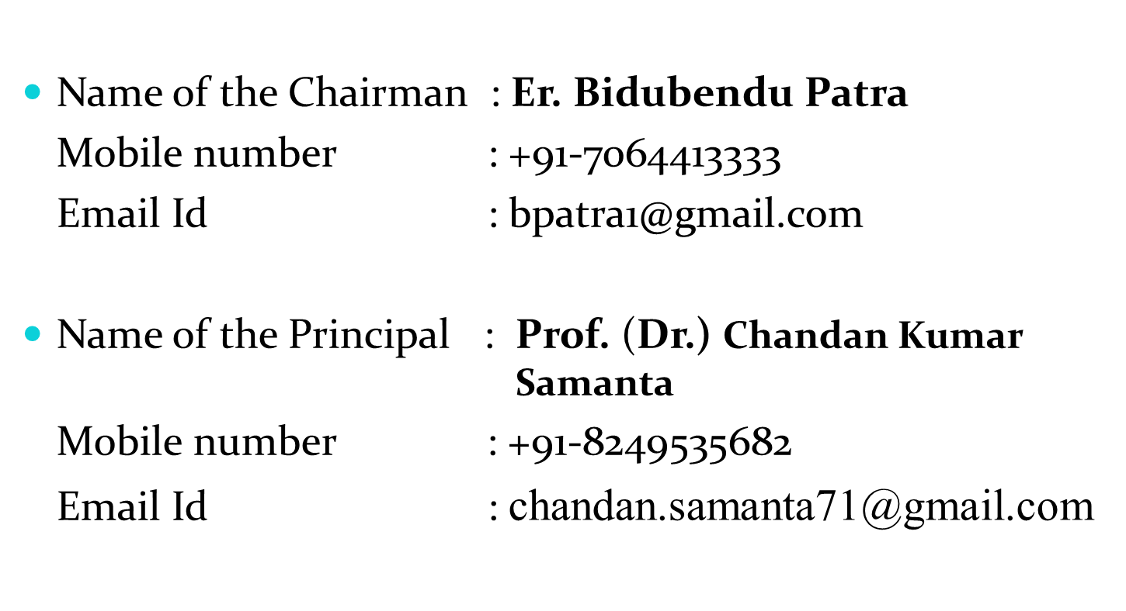
Composition of the Board of Governors

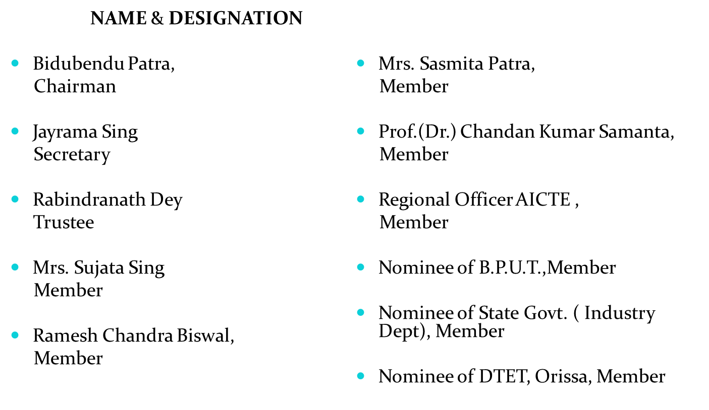

Details of Principal

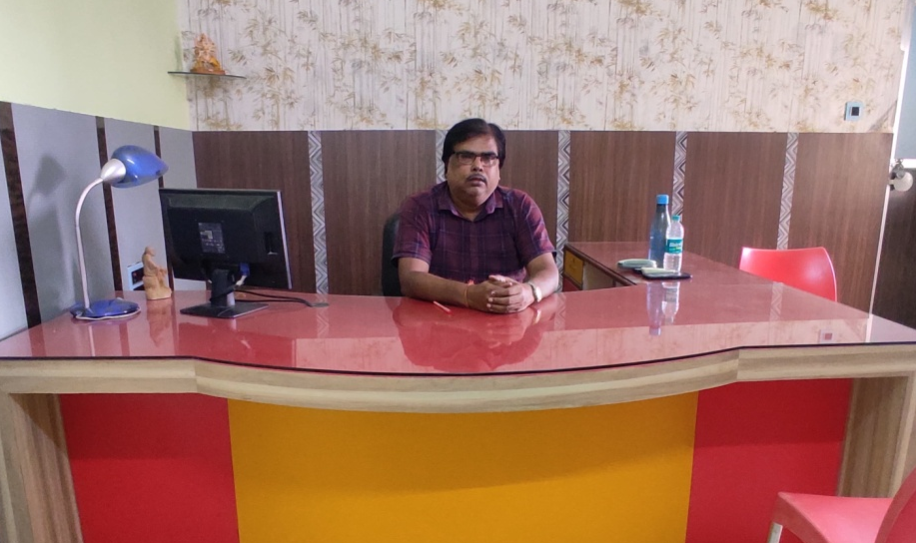

Principal Name | Dr. Chandan Kumar Samanta
Email ID | chandan.samanta71@gmail.com
Address | Jagannathpur New Colony,  Bhadrak,756100
Date of Appointment | 06/11/2023
Appointment Type | Regular
Degree | M.Tech. Ph.D.
Specialization | Electrical Engineering
Teaching Experience in Years | 32
Research Experience in Years | 10

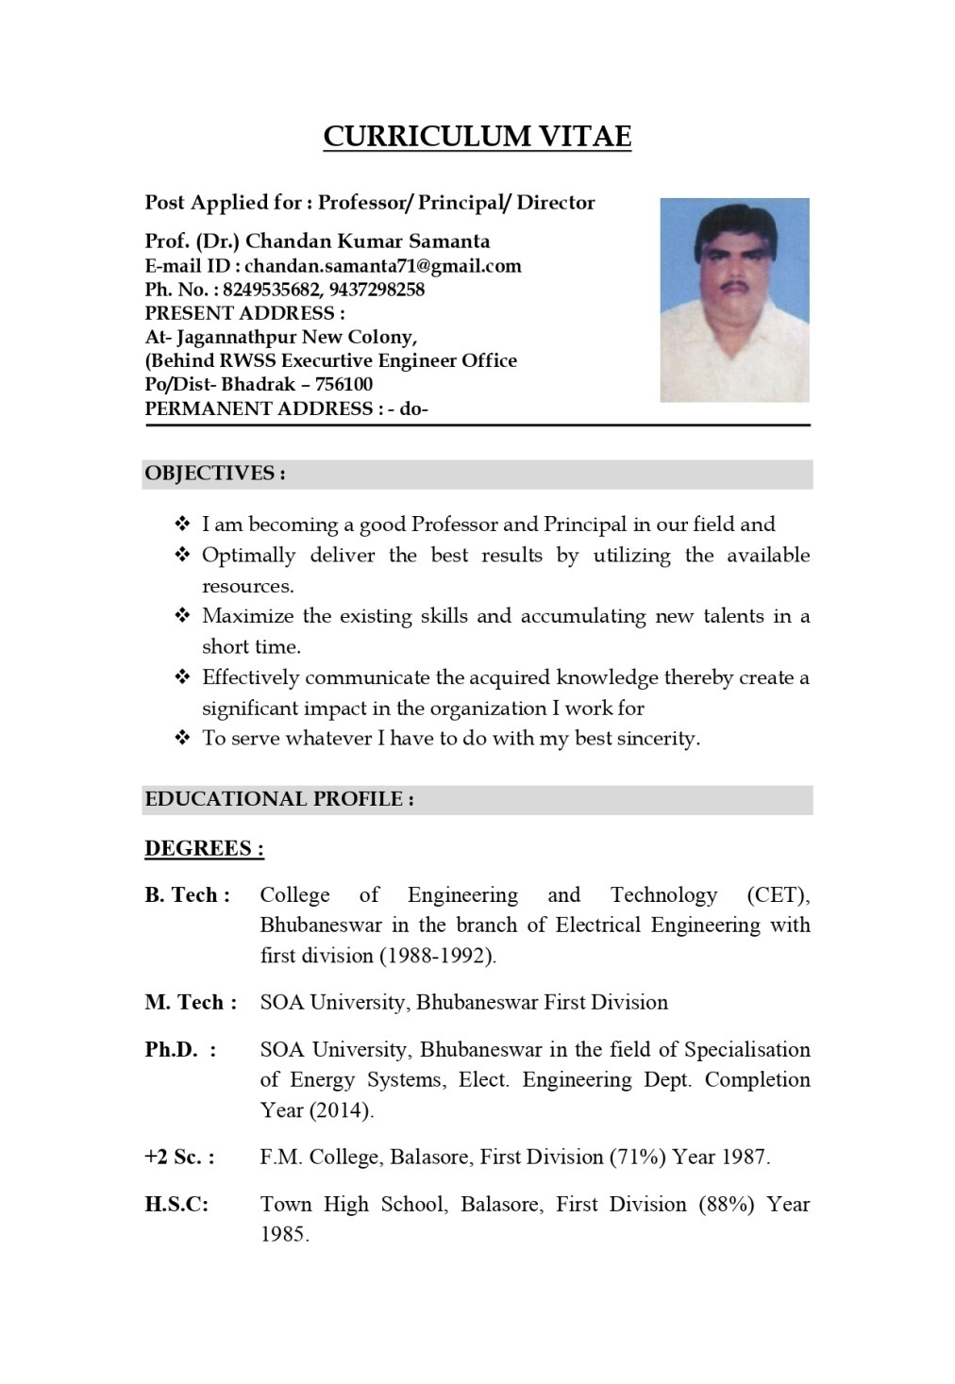
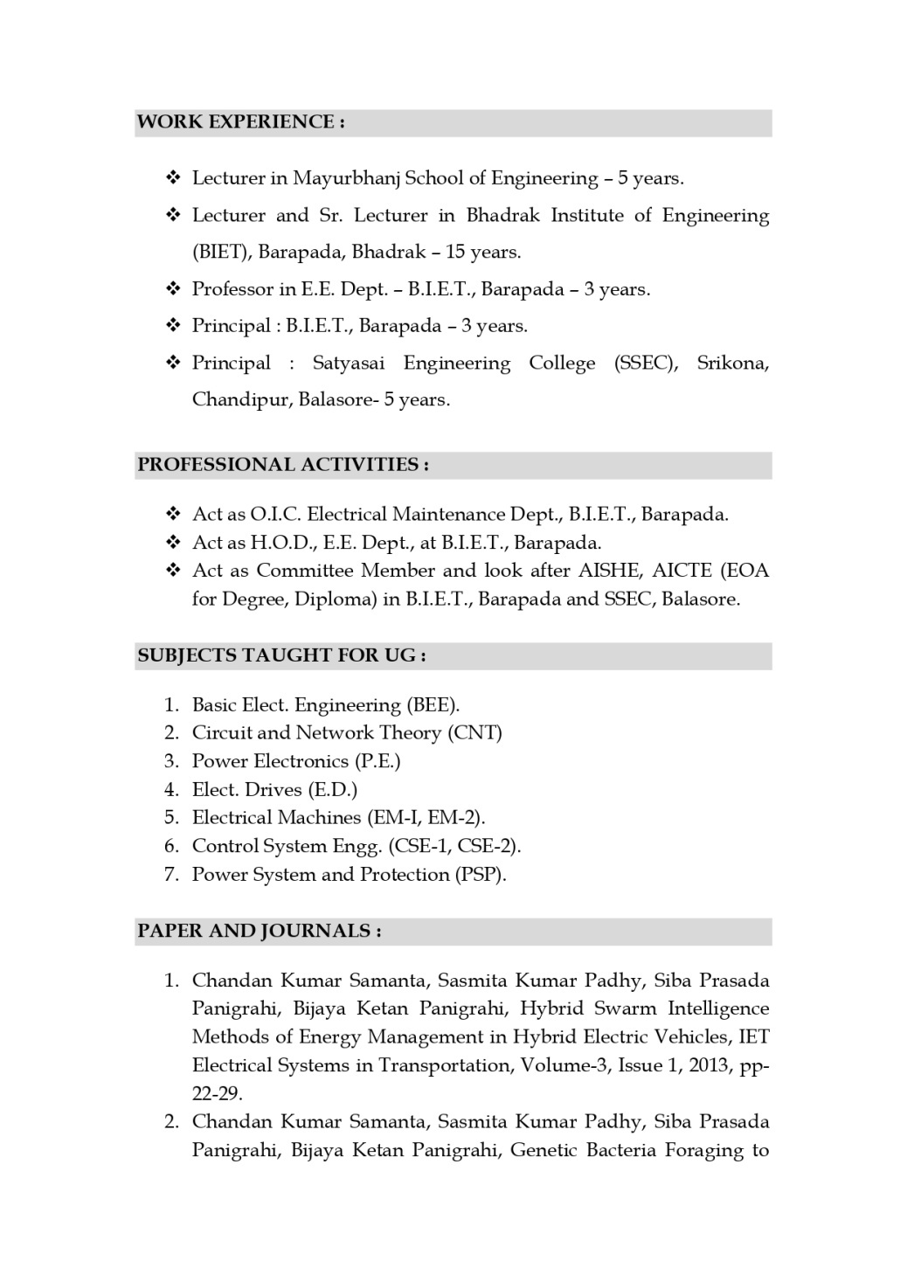
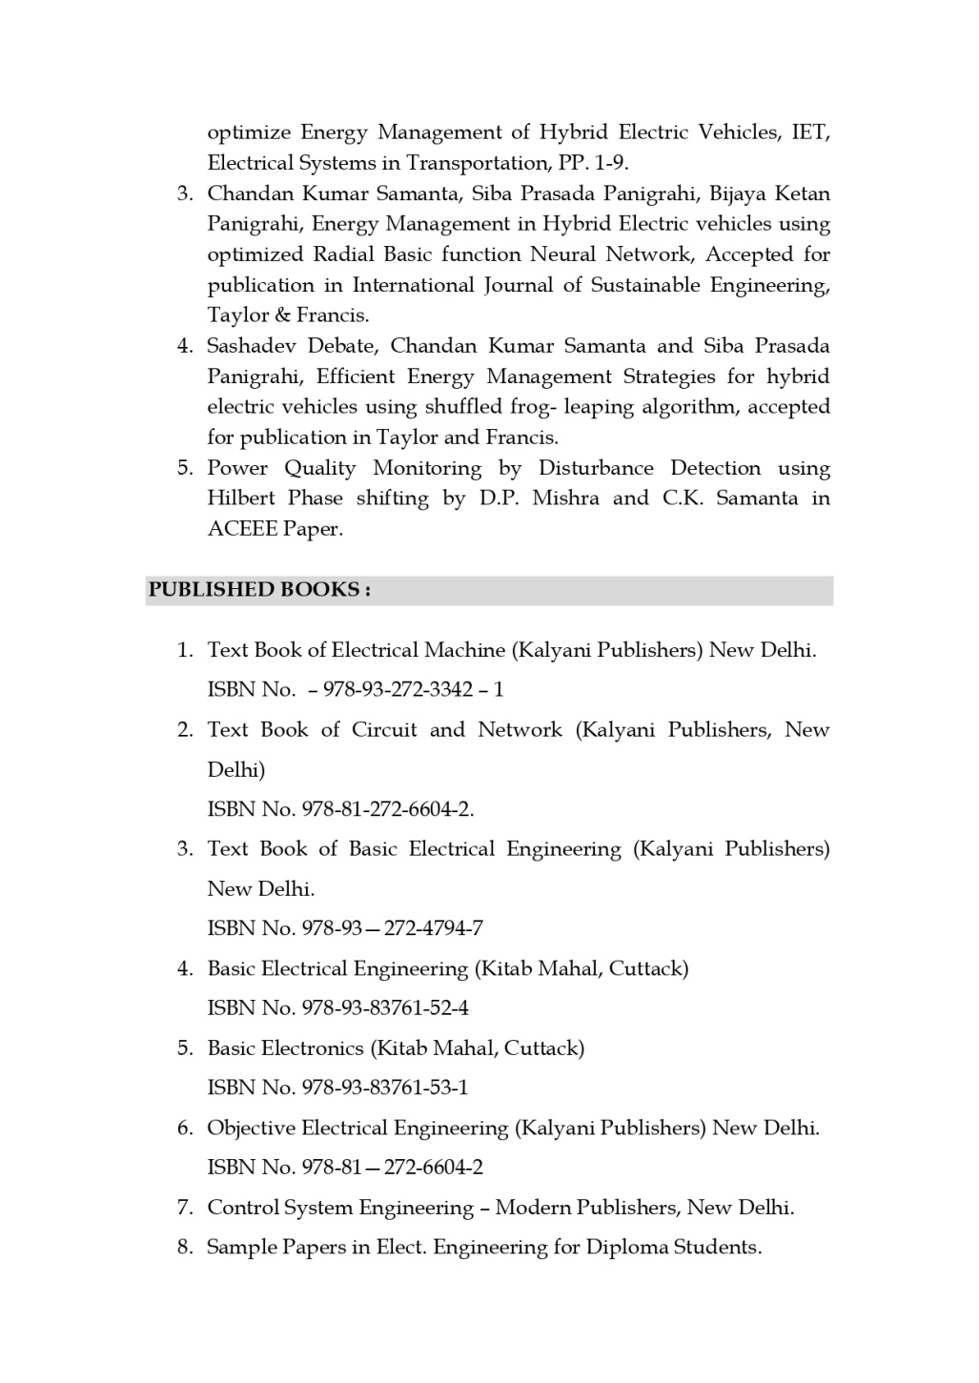

Different Committee/Cell
The Patent Committee

Patent Committee is being constituted in Vijayanjali Institute of Technology, Balasore (College Code-343), with the following members enlisted below:
- Dr. Kousik Polley – (Asst. Prof. - Department of Science and Humanities)
- Dr. Nisith Kumar Goswami- (Asst. Prof. -Department of Mechanical Engineering)
- Dr. Sitaram Pani (Prof.-Department of Science and Humanities)

Entrepreneurship Development Cell
Entrepreneurship Development Cell is being constituted in Vijayanjali Institute of Technology, Balasore (College Code-343), with the following members enlisted below:
- Dr. Sitaram Pani (Prof.-Department of Science and Humanities)
- Mr. Diptiranjan Panda (Asst. Prof.- Department of Science and Humanities)

Student Counselling Cell
Student Counselling Cell is being constituted in Vijayanjali Institute of Technology, Balasore (College Code-343), with the following members enlisted below:
- Mr. Pabitra Mohanty – (Asst. Prof. -Department of Mechanical Engineering)
- Mr. Satya Narayan Mohanty- (Asst. Prof.-Department of Civil Engineering)
- Mr. Sanjay Ku. Sahoo- (Asst. Prof. -Department of Mechanical Engineering)

